ALUMNI – CLASS OF 2001
Judy L Blowe 04/05/2001
James E Campbell 04/05/2001
Jackie H Gerrior 04/05/2001
Joshua J Harrison 04/05/2001
Debora E Hileman 04/05/2001
Timothy N Hopkins 04/05/2001
Marla Johnson 04/05/2001
Robert L Johnston 04/05/2001
Shirley A Joyce 04/05/2001
Shirley Matlock 04/05/2001
Sue D Pakulla 04/05/2001
Barbara S Payton 04/05/2001
Jon E Phillips 04/05/2001
Beverly Rasmussen 04/05/2001
Elizabeth A Rhodes 04/05/2001
Jeffrey Z Slavin 04/05/2001
Edward J Smith 04/05/2001
Andrew Van Den Heuvel 04/05/2001
Patricia A Waggoner 04/05/2001
Charles W Windsor 04/05/2001

Class of 2001
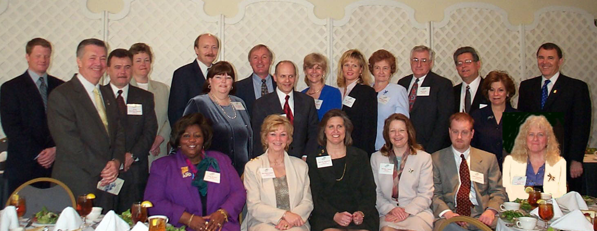

Left to Right - Standing: James E. Campbell, Adam D. Cockey, Jr., 2001 MAR President, Andrew Van Den Heuvel, Marla Johnson, Robert L. Johnston, Sue D. Pakulla, Charles W. Windsor, Jeffrey Z. Slavin, Patricia A. Waggoner, Debora E. Heilman, Barbara S. Payton, Edward J. Smith, Jon E. Phillips, Ilene S. Kessler, Chair, 2001 MAR Leadership Academy, Richard A. Mendenhall, 2001 NAR President.
Left to Right - Seated: Judy L. Blowe, Beverly Rasmussen, Shirley L. Matlock, Shirley A. Joyce, Joshua J. Harrison, Jackie H. Gerrior.
Not Present - Elizabeth A. Skidmore

ALUMNI – CLASS OF 2002
Paul J Aldridge Jr 04/18/2002
George W Brookhart 04/18/2002
Melvina Brown 04/18/2002
Collette B Cavegn 04/18/2002
Patricia A Coan 04/18/2002
James C Diamond 04/18/2002
Thomas M Ettz 04/18/2002
Elizabeth A Green 04/18/2002
Norman L Hatfield Jr. 04/18/2002
Oliver T Henderson Sr 04/18/2002
M Steve Jacobson 04/18/2002
Charles W Kraus 04/18/2002
David E Maclin 04/18/2002
Susan A Padgett 04/18/2002
Joel T Pautsch 04/18/2002
Frank M Powell 04/18/2002
Silvia S Rodriguez 04/18/2002
Patricia Smallwood 04/18/2002
Maria A Terry 04/18/2002
Gary L Vreeland 04/18/2002
Frederick L Washburn 04/18/2002

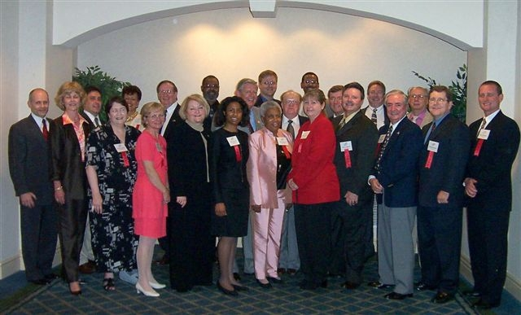
Class of 2002

Front Row - L to R - Jeffrey Slavin, Co-Chair; Patricia Waggoner, Co-Chair; Silvia S. Rodriguez, Elizabeth A. Green, Collette B. Yarashus, Maria A. Terry, Melvina Brown, Patricia B. Smallwood, Gary L. Vreeland, Thomas M. Ettz, George W. Brookhart, Paul J. Aldridge, Jr.
Back Row - L to R - James C. Diamond, Patricia A. Coan - Recipient of W. H. C. Wilson Scholarship, Frank M. Powell, David E. Maclin, William J. Neary, Jr., 2002 MAR President, Joel T. Pautsch, Frederick L. Washburn, Oliver T. Henderson, Sr., Charles W. Kraus, Norman L. Hatfield, Jr., M. Steve Jacobson
Not Present: Susan A. Padgett

ALUMNI – CLASS OF 2003
Cuvator H Armstrong 05/22/2003
Ann C Bangert 05/22/2003
Antionette Braglio 05/22/2003
Kristin Gerlach 05/22/2003
Christine A Giglio 05/22/2003
Elaine B Gordy 05/22/2003
John A Hurly 05/22/2003
Mary Frances F McColgan 05/22/2003
Krenda L Weisenmiller 05/22/2003
Dennis B Melby 05/22/2003
Arlene C Murray 05/22/2003
Bea P Rodgers 05/22/2003
Gerrie M Sims 05/22/2003
Robert B Sommers 05/22/2003
Connie M Stommel 05/22/2003
Charles F Sullivan 05/22/2003
Reata B Swanson 05/22/2003
Patrick A Weed 05/22/2003
Jeffrey M Weese 05/22/2003
Patricia D Weller 05/22/2003
Susan E Zorn 05/22/2003

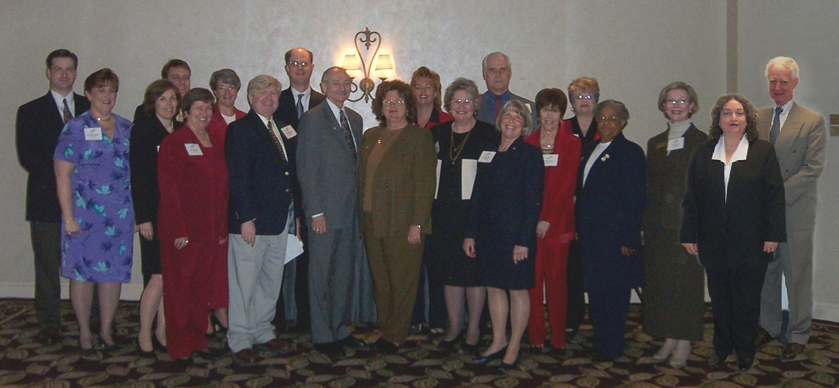
Class of 2003

Back Row – Left to Right – Robb Sommers, Jeff Weese, Ann Bangert, Charles Sullivan, Krenda Weisenmiller, John Hurly, Toni Braglio
Front Row – Left to Right - Fran McColgan, Kristin Gerlach, Bea Rodgers, Dennis Melby, Walt McDonald, 2003 NAR President-Elect, Gloria Farrar, 2003 MAR President, Connie Stommel, Susan Zorn, Gerrie Simms, “Q” Armstrong, Recipient of W.H.C. Wilson Scholarship, Chris Greto, Arlene Murray, Pat Weed
Not Present: Reata Swanson, Patty Weller

ALUMNI – CLASS OF 2004
Ginger C Allen 04/20/2004
Wendy Aloi 04/20/2004
Deborah L Borror 04/20/2004
Chris W Haddaway 04/20/2004
Scott M Lederer 04/20/2004
Aaron J Marsh 04/20/2004
Julia Mattis 04/20/2004
Barbara F Miles 04/20/2004
Melanie Pratt Dimaio 04/20/2004
Jamie M Rice 04/20/2004
Lawrence R Riggs 04/20/2004
James P Schaecher 04/20/2004
Kenneth R Snyder 04/20/2004
Patricia A Terrill 04/20/2004
Frederick A Thoms Sr 04/20/2004
Sarah E Toppins 04/20/2004
Jan M Waddell-Brown 04/20/2004

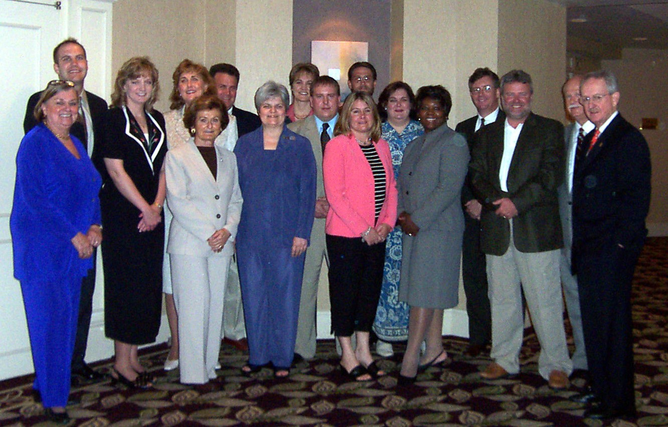
Class of 2004

Back Row – Left to Right: Aaron J. Marsh, Deborah L. Borror, Julia Mattis, Timothy N. Hopkins, Ginger C. Allen, James P. Schaecher, Kenneth R. Snyder, Melanie P. Dimaio, Scott M. Lederer, Frederick A. Thoms, Sr.
Front Row – Left to Right: Anne S. Cooke, 2004 Academy Chair, Barbara F. Miles, Sara E. Toppins, Jamie M. Rice, Jan Waddell-Brown, Recipient of W.H.C. Wilson Scholarship, Chris W. Haddaway, Martin Edwards, Jr., 2002 NAR Past President,
Not present: Wendy Aloi, Larry R. Riggs, Patricia A. Terrill

ALUMNI – CLASS OF 2005
Rusling D Blackburn 04/19/2005
Mary Calder 04/19/2005
Carol Sue Crimmins 04/19/2005
Melanie Gamble 04/19/2005
Daniele C Griffith 04/19/2005
Thomas H Hough 04/19/2005
Patricia D Howard 04/19/2005
Karyn K Keating-Volke 04/19/2005
Bob Kimball 04/19/2005
Anita L Land 04/19/2005
Nicole D Lapera-Holler 04/19/2005
Barbara M Linthicum 04/19/2005
Jeffrey A Matthews 04/19/2005
Kenneth R Montville 04/19/2005
Diane M Olsen 04/19/2005
Dorcas M Quynn 04/19/2005
Linda F Simpson 04/19/2005
Donna A Turing 04/19/2005

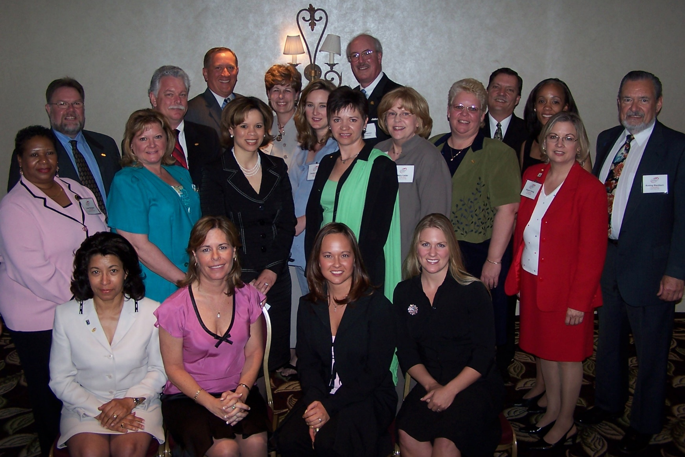
Class of 2005

Left to Right - Top Row: Kenneth R. Montville, Thomas H. Hough, Robert P. Kimball, Barbara M. Linthicum, Danielle C. Griffith,
Alan R. Ingraham, 2005 MAR President-Elect, Jeffrey A. Matthews, Leslie M. Greer, Rusling D. Blackburn
Second Row: Linda F. Simpson, Karyn Keating-Volke, Melanie Gamble, Diane M. Olsen, Mary Calder, CarolSue Crimmins,
Donna A. Turing
Seated: Anita L. Land, Patricia D. Howard, Nicole D. Lapera, Recipient of W.H.C. Wilson Scholarship, Dorcus M. Quynn

ALUMNI – CLASS OF 2006
John G Allen 04/18/2006
James H Billingslea Jr 04/18/2006
Alease R Bowles 04/18/2006
Sherwood T Brooks 04/18/2006
Julian Coiner 04/18/2006
Lisa E Faith 04/18/2006
Melinda Gossard 04/18/2006
Stephanie A Hodges 04/18/2006
Diane M Marsden 04/18/2006
Kathleen A Miller 04/18/2006
Donna Moffett 04/18/2006
Sandy L Moreland 04/18/2006
Judy A Plowman 04/18/2006
Melinda K Roark 04/18/2006
Robert R Rossi 04/18/2006
Bianca M Smith 04/18/2006
Richard A Trott 04/18/2006
Ruth C Wright 04/18/2006

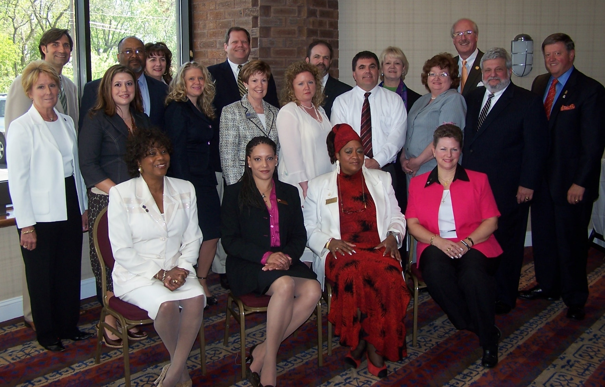
Class of 2006

Back Row – L to R – Julian Coiner, John G. Allen, Diane M. Marsden, Sherwood “Duke” T. Brooks - W.H.C. Wilson Scholarship Recipient, Richard A.Trott, Jr., Sandra L. Moreland, Alan R. Ingraham – 2006 MAR President
Middle Row – L to R – Melinda K. Roark, Bianca M. Smith, Stephanie A. Hodges, Joyce A. Plowman, Melinda Gossard, James H. Billingslea, Jr., Kathleen A. Miller, Robert R. Rossi, Thomas M. Stevens – 2006 NAR President
Seated – L to R – Alease R. Bowles, Lisa E. Nordan-Haller, Ruth C. Wright, Donna Moffett

ALUMNI – CLASS OF 2007
James M Blaney 04/19/2007
Sonatta S Camara 04/19/2007
Michael F Cerrito 04/19/2007
Julie P Duley 04/19/2007
Ronald C Edelmann 04/19/2007
Leslie G Fulford 04/19/2007
Elizabeth L Glass 04/19/2007
April L Heim 04/19/2007
Dennis Helmstetter 04/19/2007
James Hyatt 04/19/2007
Michael Kurtianyk 04/19/2007
Cassandra Lewis 04/19/2007
Cassie C Mead 04/19/2007
Susan Myszkowski 04/19/2007

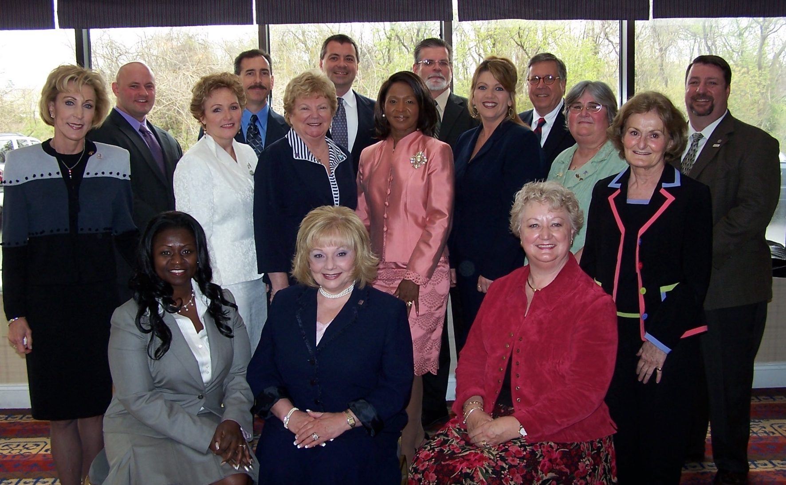
Class of 2007

Back Row - L to R - James R. Hyatt, James M. Blaney - W.H.C. Wilson Scholarship Recipient, Michael Kurtianyk, J. Dennis Helmstetter, Ronald C. Edelmann
Middle Row – L to R - Vicki Cox Golder – 2008 NAR First Vice President Nominee, Susan Myszkowski, Mary C. Mead, Cassandra Lewis, April L. Heim, Leslie G. Fulford, Barbara Miles - 2007 Chair, Michael F. Cerrito
Seated – L to R - Sonatta S. Camara, Elizabeth T. Glass, Julie P. Duley

ALUMNI – CLASS OF 2008
Humberto Benitez 04/14/2008
Kunnigunda M Biener 04/14/2008
J. Russell Boyce 04/14/2008
F Kathy Buckus 04/14/2008
Jeffrey Cline 04/14/2008
Steve L Ferguson 04/14/2008
Melba S Gaillard 04/14/2008
Charles M Gregg 04/14/2008
Charles P Hawley 04/14/2008
Richard Hebert 04/14/2008
Jason Herzberger 04/14/2008
Karol A Hess 04/14/2008
Kristin L King 04/14/2008
Shawn L Lewis 04/14/2008
Kathryn A McKenzie 04/14/2008
Joan McLernon 04/14/2008
Yolanda R Muckle 04/14/2008
Stephanie H Rall 04/14/2008
Erica L Solomon 04/14/2008
Judi Stull 04/14/2008
Merry M Tobin 04/14/2008
Sharon Wilkerson 04/14/2008

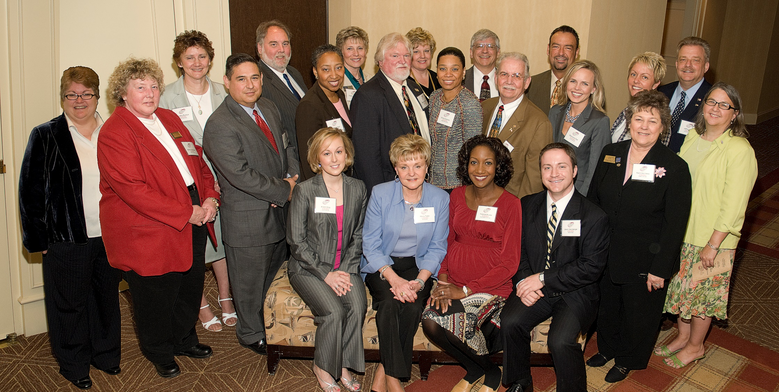
Class of 2008

Back Row: Judith C. Stull - W.H.C. Wilson Recipient, F. Kathy Buckus, Charles M. Gregg, Sharon E. Wilkerson, Shawn L. Lewis, Richard L. Hebert, J. Russell Boyce, Joan E. McLernon, and Jeffrey A. Cline.
Middle Row: Kathryn A. McKenzie, Humberto Benitez, Melba S. Gaillard, Steve L. Ferguson, Erica L. Solomon, Charles P. Hawley – David E. Maclin Humanitarian Award Recipient, Stephanie H. Rall, Karol Ann Hess and Kunnigunda M. Biener.
Front Row, seated: Kristin L. King, Merry M. Tobin, Yolanda R. Muckle and Jason C. Herzberger.

ALUMNI – CLASS OF 2009
Robert W Carney 04/14/2009
Terence F Daly 04/14/2009
Tracy Franck 04/14/2009
Mary E. Gawler 04/14/2009
Deborah A Henninger 04/14/2009
Gregg B Holland 04/14/2009
Judith E Isom 04/14/2009
Linda Kangrga 04/14/2009
Mallory Kubicek 04/14/2009
Fredericka A Lloyd 04/14/2009
Linda McKinnon 04/14/2009
Sandra M Fouche 04/14/2009
Richard M Rall Jr. 04/14/2009
Paula B Reeder 04/14/2009
Bob Simon 04/14/2009
Sue Stouffer 04/14/2009
Noel T Wood 04/14/2009

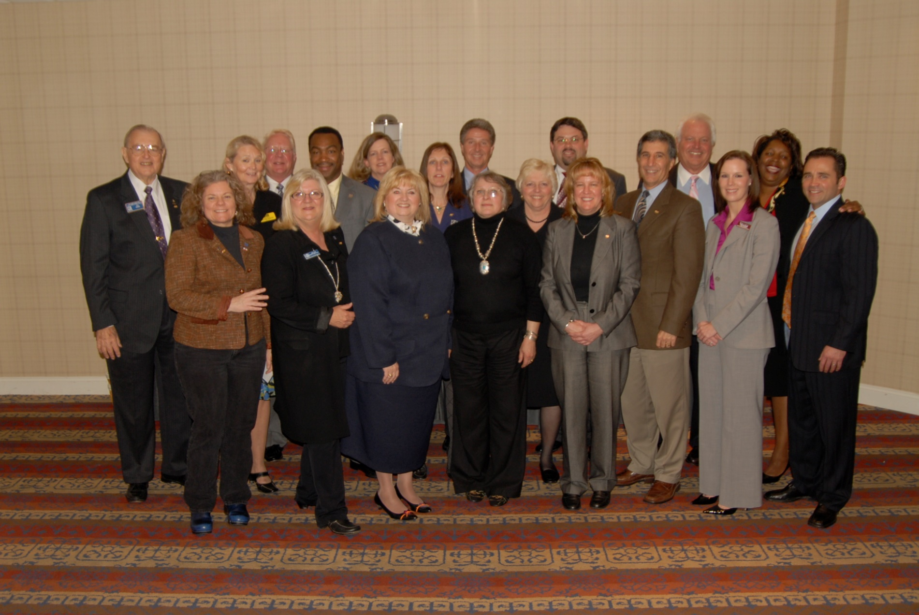
Class of 2009

Back Row – L to R: Noel T “Tim” Wood – David E. Maclin Humanitarian Award Recipient, Mallory M. Kubicek, Gregg B. Holland, Mark Foreman – 2009 NAR Law & Policy Liaison, Tracy Franck, Deborah A. Henninger, Terrance “Terry” F. Daly, Robert W. Carey, Stephen Meszaros, 2009 MAR President-Elect, Fredericka A. Lloyd
Front Row – L to R: Linda A. Kangrga, Judith E. Ison, Sue E. Stouffer, Paula B. Ruckelshaus, Linda McKinnon – W.H.C. Wilson Scholarship Recipient, Sandra M. Fouche, Bob Simon, Mary E. “Meg” Gawler, Richard M. Rall, Jr.

ALUMNI – CLASS OF 2010
Lane A Chaisson 04/27/2010
Lou Ramsay Cotta 04/27/2010
Jennifer L Cropper-Rines 04/27/2010
Marianne S Ferguson 04/27/2010
Shari Gaister 04/27/2010
Janet J Greene 04/27/2010
Susan E Hale 04/27/2010
Doris Hall-Scheeler 04/27/2010
Tim Hodgin 04/27/2010
David Lidz 04/27/2010
Tasha Linton 04/27/2010
George E Mitchell 04/27/2010
Christopher B Richardson 04/27/2010
Marie E Shantz 04/27/2010
Kenneth Smallwood 04/27/2010
Pamela D Stone 04/27/2010
Jeanne L Turnock 04/27/2010
Pam Wadler 04/27/2010

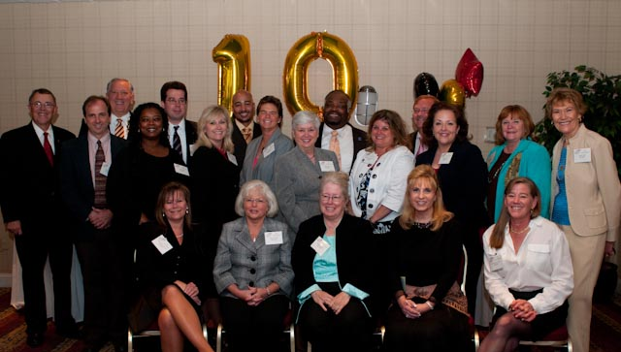
Class of 2010

Back Row, L to R – Richard Mendenhall - NAR 2001 President, Bob Kimball - MAR 2010 Chair, Tim Hodgin, Christopher B. Richardson, George E. Mitchell, Kenneth W. Smallwood
Middle Row Standing, L to R – David Lidz, Tasha Linton – The David E. Maclin Humanitarian Award Recipient, Doris Hall-Scheeler, Lane A. Chaisson, Janet L. Greene, Jennifer L. Cropper-Rines, Pamela D. Stone, Pamela J. Wadler, Susan E. Hale,
Seated, L to R – Marianne S. Ferguson – W.H.C. Wilson Scholarship Recipient, Marie E. Shantz, Jeanne L. Turnock, Shari Gaister and Lou Ramsay Cotta

ALUMNI – CLASS OF 2011
Cheryl D Abrams 04/19/2011
Darren T Ahearn 04/19/2011
Gretchen Conley 04/19/2011
Neda R Cox 04/19/2011
Lisa M Goodman 04/19/2011
Kim Jones 04/19/2011
Sue M Kalons 04/19/2011
Leigh Lawson 04/19/2011
John L Lesniewski 04/19/2011
Jeremy Loomis 04/19/2011
Simon N Nwaigwe 04/19/2011
Hildegarde M Pollard 04/19/2011
Marilyn Rhodovi 04/19/2011
Debra A Swann 04/19/2011
Karen Thomas 04/19/2011
Jennifer Utz 04/19/2011
David R Vane 04/19/2011

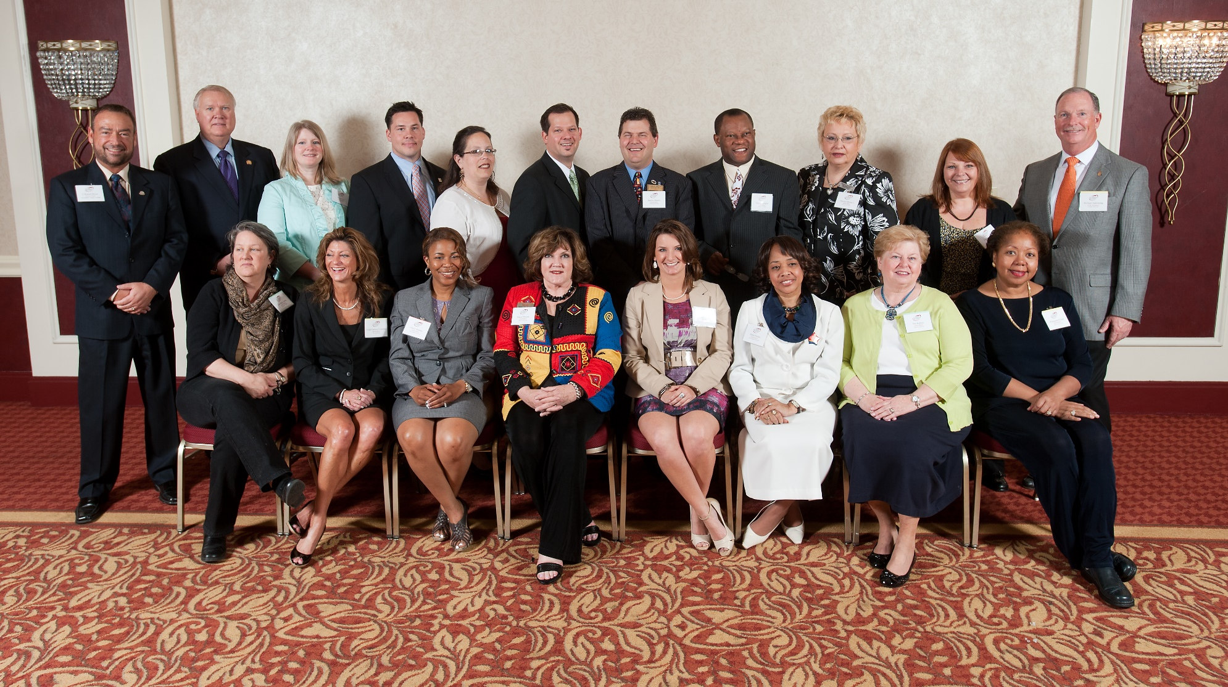
Class of 2011

Back Row, L to R: J. Russell Boyce, Chairman; Dale Stinton, NAR CEO; Neda R. Cox; David R. Vane - The David E. Maclin Humanitarian Award Recipient; Kim Jones; T. Jeremy Loomis; Darren T. Ahearn; Simon N. Nwaigwe – The W. H. C. Wilson Memorial Scholarship Recipient; Marilyn Rhodovi; Lisa M. Goodman; and, William J. Armstrong, III, NAR 2011 Treasurer
Seated, L to R: Gretchen L. Conley; Leigh Lawson-Everstine; Cheryl D. Abrams; Karen Thomas; Jennifer Utz; Debra A. Swann; Sue M. Kalons; and, Hildegarde M. Pollard
Not Present: John L. Lesniewski

ALUMNI – CLASS OF 2012
Amanda Addington 04/17/2012
Nancy S Allen 04/17/2012
Jeri Benner 04/17/2012
Rodney Bennett 04/17/2012
Lynette L Bridges-Catha 04/17/2012
LaCrisha Butler 04/17/2012
Samar D Caverly 04/17/2012
Stephen G Cooper 04/17/2012
Alicyn DelZoppo 04/17/2012
Sharron Dorsey 04/17/2012
Ivy K Gifford 04/17/2012
Elizabeth M Hays 04/17/2012
Suzanne M Hitt 04/17/2012
Daniel E Hoff 04/17/2012
Susan B Megargee 04/17/2012
Linda A Moran 04/17/2012
Rachel Nichols 04/17/2012
Dennis G Phillips 04/17/2012
Edward H Robinson 04/17/2012
Sharon A McKenna 04/17/2012
Kevin Turner 04/17/2012

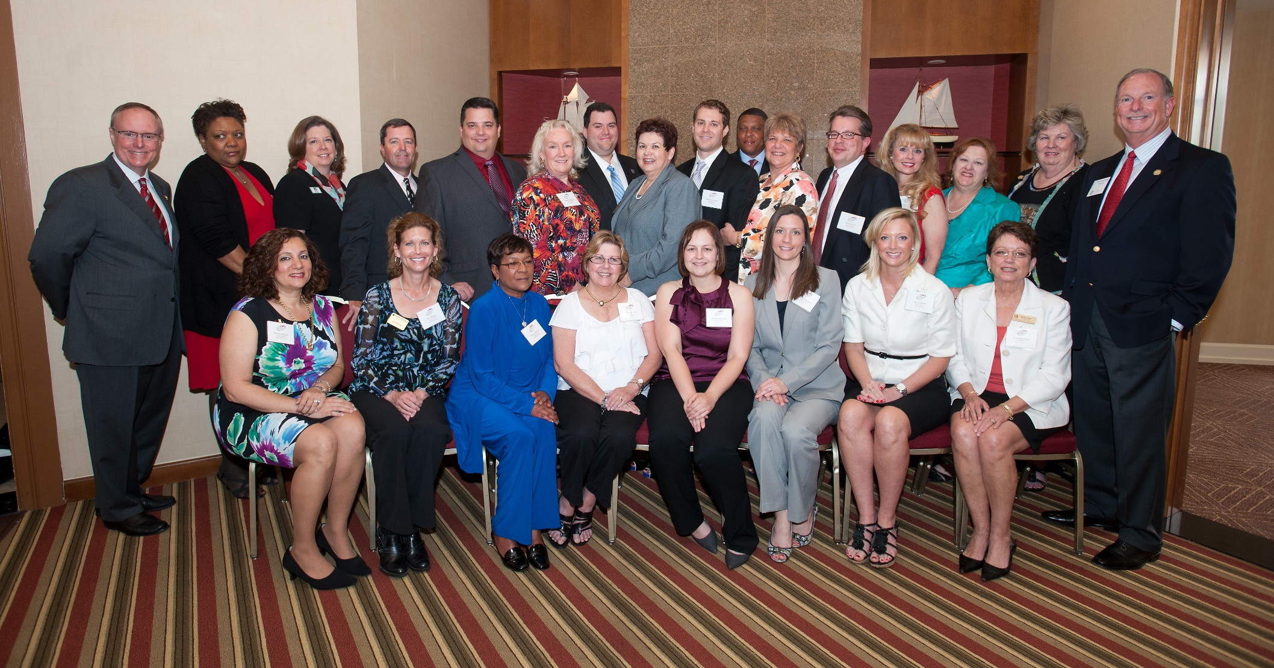
Class of 2012

Back Row, L to R - Steve Brown, NAR 2012 First Vice President, LaCrisha Butler, Suzanne M. Hitt, Greg Phillips, Edward H. Robinson, Susan B. Megargee, Kevin Turner, Sharon A. McKenna - W.H.C. Wilson Scholarship Recipient, Stephen G. Cooper, Rodney Bennett, Lynette L. Bridges-Catha - David E. Maclin Award Recipient, Daniel E. Hoff, Nancy S. Allen, Rachel B. K. Nichols, Pat Terrill, MAR 2012 President; and, William J. Armstrong, III, NAR 2012 Treasurer
Seated, L to R – Samar D. Caverly, Jeralynn Benner, Sharron Dorsey, Linda A. Moran, Alicyn C. DelZoppo, Amanda Addington, Ivy K. Gifford, and Elizabeth M. Hays

ALUMNI – CLASS OF 2013
Coard A Benson 04/16/2013
Aprile D Crawford 04/16/2013
Judith A Gordon 04/16/2013
Jennifer C Grove 04/16/2013
Diane W Hayes 04/16/2013
Claude H Humbert 04/16/2013
Thomas P Levin 04/16/2013
Joel M Maher 04/16/2013
Renee Mankoff 04/16/2013
Gary G Nelson 04/16/2013
Hai Nguyen 04/16/2013
Stephen T Paul 04/16/2013
Pramedai K Reed 04/16/2013
Brenda Scarborough 04/16/2013
Demetria Scott 04/16/2013
Craig J Strobel 04/16/2013
Rose G Thomas 04/16/2013
Lisa Van Tassel 04/16/2013

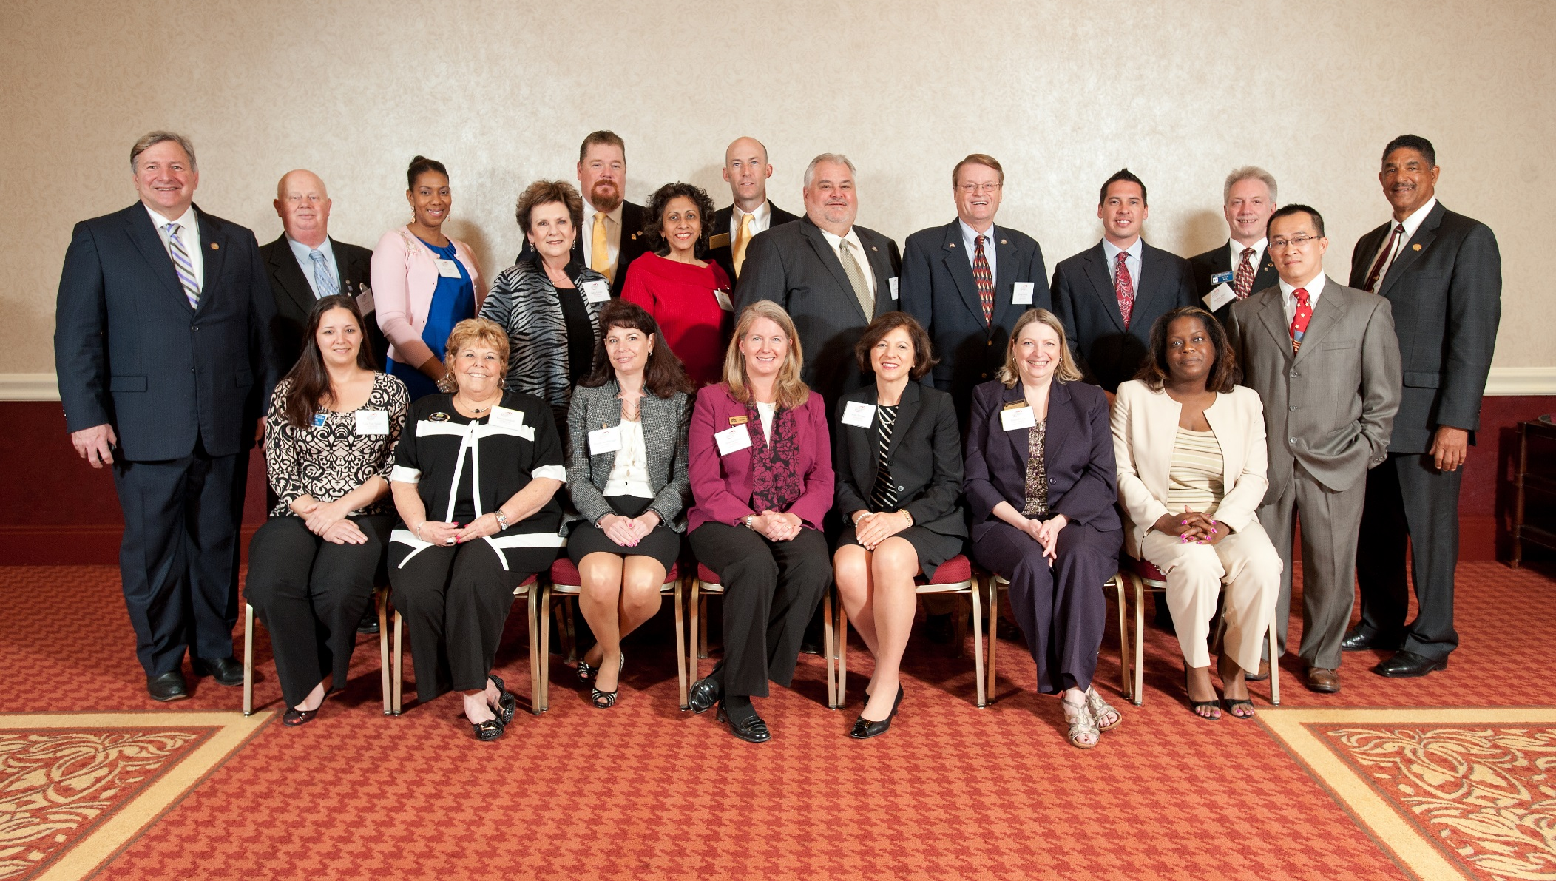
Class of 2013
Left to Right – Standing: Ronald L. Phipps - NAR 2011 President, Gary G. Nelson, April D. Crawford, Judith A. Gordon, Thomas P. Levin, Pramedai K. Reed, Coard A. Benson, Claude H. Humbert, Craig J. Strobel, Joel M. Maher, Stephen T. Paul, Hai Nguyen, Carlton J. Boujai – MAR 2013 President
Left to Right – Seated: Lisa Van Tassel, Renee Mankoff, Brenda Scarborough, Jennifer C. Grove, Rose G. Thomas, Diane W. Hayes, Demetria Scott

ALUMNI – CLASS OF 2014
JoAnn Alexander 05/07/2014
Donald E Bailey 05/07/2014
Rachelle A Bartlett 05/07/2014
Jan Brito 05/07/2014
Diana Carlson 05/07/2014
Thomas P Coard 05/07/2014
John A Coller 05/07/2014
Wesley Cox 05/07/2014
Samantha A Grimes 05/07/2014
John A Harrison 05/07/2014
Jo-Ann Henry 05/07/2014
Adam Hyp 05/07/2014
Denise M Lewis 05/07/2014
Moquit A Malik 05/07/2014
Kimberly Mills 05/07/2014
Maria D Sasso 05/07/2014
RoseAnn C Spalt 05/07/2014
Donna Weaver 05/07/2014
Blaine L Williamson 05/07/2014
Gwendolyn Wynn 05/07/2014

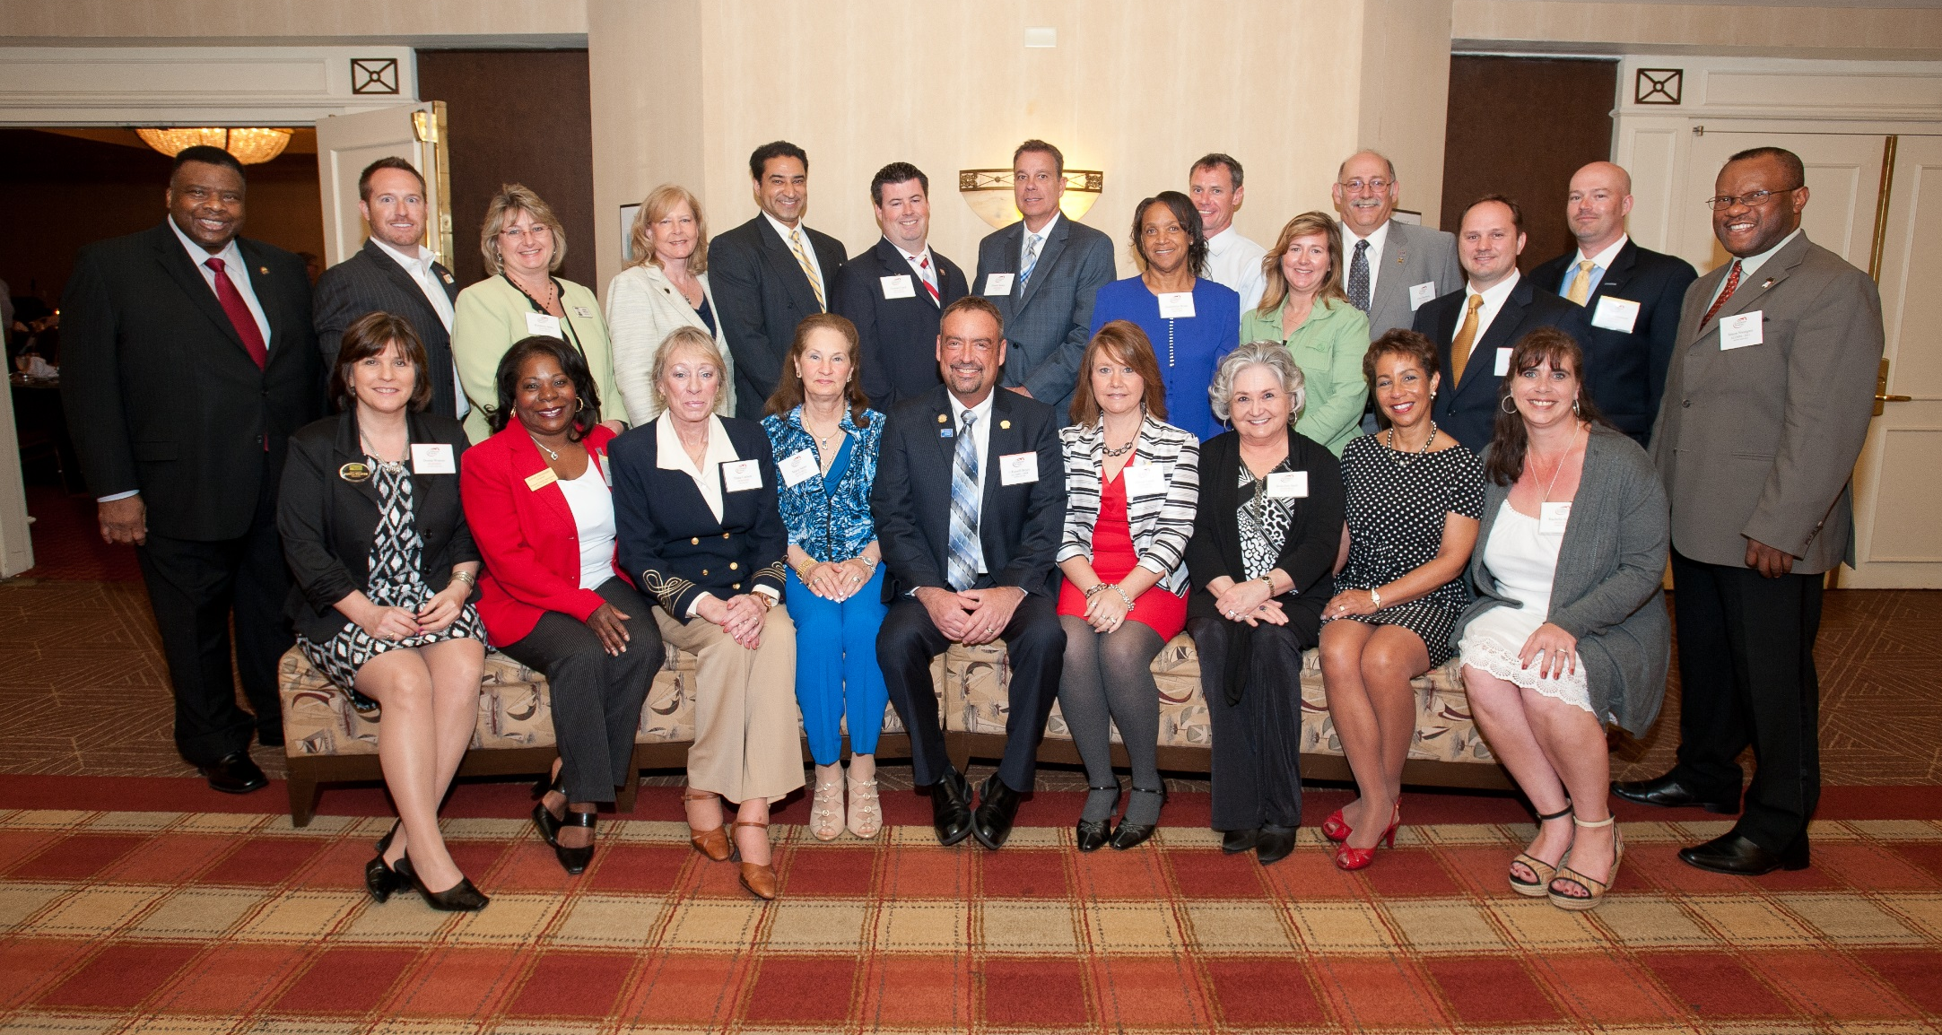
Class of 2014

Back Row Standing – Left to Right – Charles McMillan, NAR 2009 President; Wesley Cox; Kimberly A. Mills; A. Jan Brito; Moquit A. Malik; Thomas P. Coard; Donald E. Bailey; Gwendolyn Wynn; Adam S Hyp; Samantha A. Grimes; John A. Harrison; John A. Coller, Blaine W. Williamson; and, Simon Nwaigwe, 2014 Advisory Group Chair.
Front Row Seated – Left to Right – Donna L. Weaver; JoAnn M. Alexander; Diana W. Carlson; Maria D. Sasso, J. Russell Boyce, MAR 2014 President; Denise M. Lewis; RoseAnn C. Spalt; Jo-Ann Henry; and, Rachelle A. Bartlett.

ALUMNI – CLASS OF 2015
Michelle W Abplanalp 04/15/2015
M Jacqueline J Bennett 04/15/2015
Anita J Blye 04/15/2015
Gregory D Fisk 04/15/2015
Pamela Harrison 04/15/2015
Steven Huffman 04/15/2015
Jennifer D Jones 04/15/2015
Michele L McCartin 04/15/2015
Terrence B McGowan 04/15/2015
Bryant K Meldrum 04/15/2015
Veera Phillips 04/15/2015
Jacqueline Sellers 04/15/2015
Heather Shai 04/15/2015
Sandra J Smith 04/15/2015
Sheila Washburn 04/15/2015
Tyrone A Whitby 04/15/2015

Class of 2015
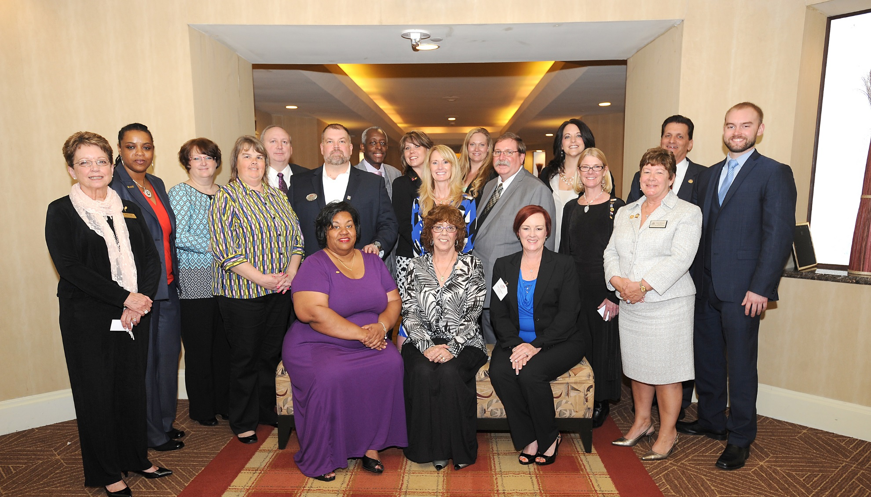

Front Row Seated – Left to Right: Veera Phillips, The David E. Maclin Humanitarian Award Recipient; Pamela Harrison, the W.H.C. Memorial Scholarship Recipient; Sheila Washburn
Back Row Standing: Betty Hays, 2015 Chair; Jacqueline Bennett; Sandra Smith; Michelle Abplanalp; Bryant Meldrum; Gregory Fisk; Tyrone Whitby; Jennifer Jones; Jacqueline Sellers; Heather Shai; Terrance McGowan; Michelle McCartin; Anita Blye; Janice Kirkner, 2015 MAR President; Tom Salomone, 2015 NAR President-Elect; and, Steve Huffman

ALUMNI – CLASS OF 2016
Desmond K Aberdeen 04/19/2016
Abeer A. Abou Elmakarem 04/19/2016
Phyllis Adam 04/19/2016
Biana J Arentz 04/19/2016
Joseph Bird 04/19/2016
Delaine Campbell 04/19/2016
Leon T Delorme 04/19/2016
Diane Donnelly 04/19/2016
Victoria Fitch 04/19/2016
George B Hall 04/19/2016
Julie M Kelley 04/19/2016
Emiliana V Lobos-Kirker 04/19/2016
Jonathan K Mason 04/19/2016
Sean Monahan 04/19/2016
Erin Phelps 04/19/2016
Cecelia M Sage 04/19/2016
Stuart M Schmidt 04/19/2016
Marian R Staab 04/19/2016
Barbara J Swanhart 04/19/2016
Brigit R Taylor 04/19/2016
Joseph B Wilson 04/19/2016
Craig Wolf 04/19/2016

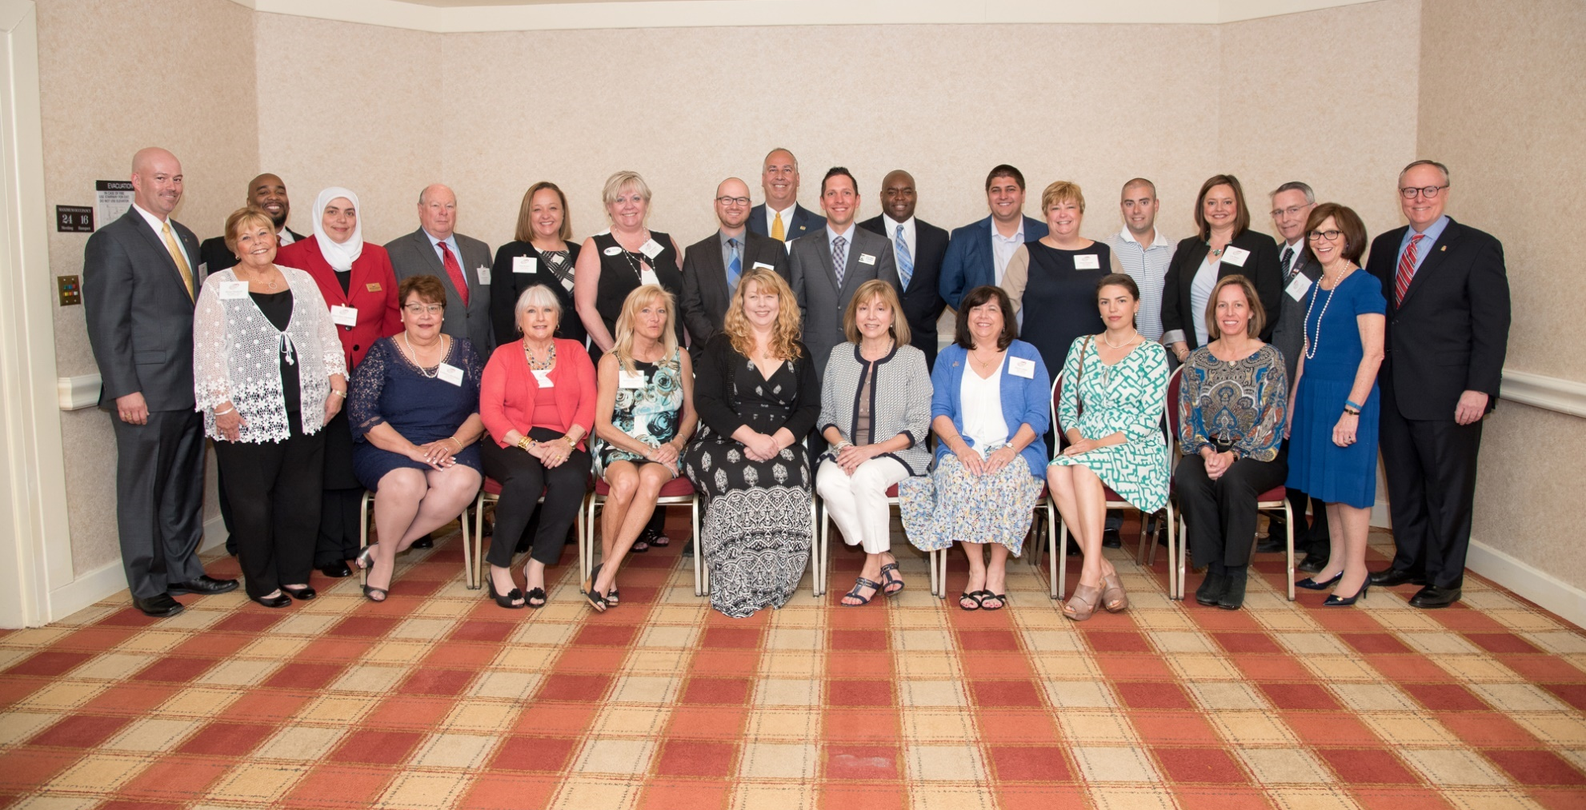
Class of 2016

Front Row Seated – L to R: Victoria Lobos-Kirker; Delaine Campbell; Barbara Swanhart; Cecelia Sage; Biana Arentz; Phyllis Adam; Victoria Fitch; and, Brigit Taylor
Back Row Standing – L to R: Blaine Williamson, Vice Chair, Academy Advisory Group; Renee Mankoff, Chair, Academy Advisory Group; Desmond Aberdeen, Abeer Abou Elmakarem; Leon Delorme; Julie Kelley; Marian Staab; Joseph Bird; Craig Wolf; Stuart Schmidt, W.H.C. Wilson Memorial Scholarship Recipient; Jonathan Mason; Joseph Wilson, The David E. Maclin Humanitarian Award Recipient; Diane Donnelly; Sean Monahan; Erin Phelps; George Hall, Bonnie Casper, MAR 2016 President; and, Steve Brown, NAR 2014 President

ALUMNI CLASS OF 2017
Sarah D Anderson 04/18/17
Retha J Arrabal 04/18/17
Desiree A Callender 04/18/17
Daphne Lynn Cawley 04/18/17
Pieter de Dreu 04/18/17
Patricia A Dowtin 04/18/17
Christopher T Drewer 04/18/17
Marc S Fisher 04/18/17
Kelli L Hillmar 04/18/17
Scott P Malott 04/18/17
Grace P Masten 04/18/17
Kendra L McCourt 04/18/17
Lorence C Ottley, Jr. 04/18/17
Michele Phippen 04/18/17
Tammy D Rosendale 04/18/17
Heather A Schafer Adkins 04/18/17
Bridget M Scott 04/18/17
Kathy L Suite 04/18/17
Martha Witte Suss 04/18/17
Lisa B Wissel 04/18/17
David Yoder 04/18/17

Class of 2017
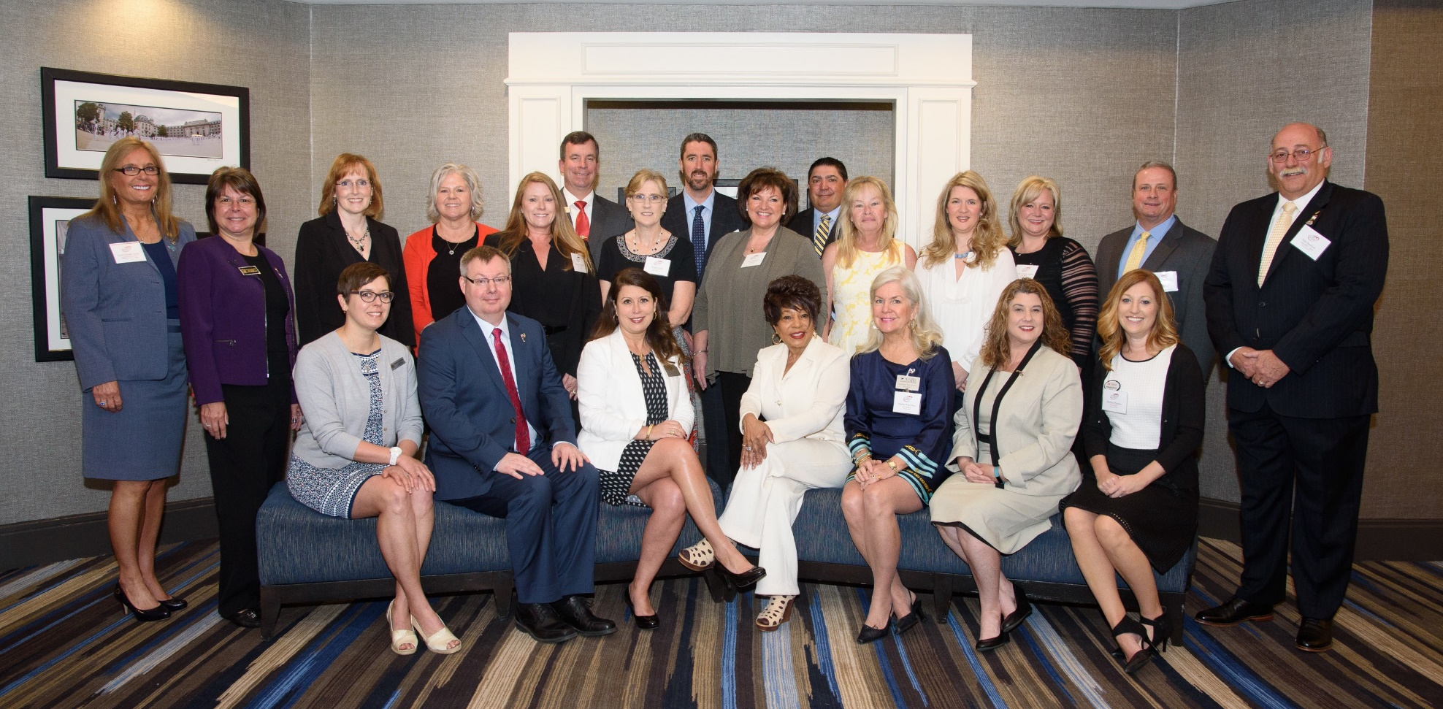

Back Row Standing – L to R – Leslie Rouda Smith, NAR Regional Vice President; Shelly Murray, MAR 2017 President; Kelli Hillmar; Retha Arrabal; Tammy Rosendale; Scott Malott; Bridget Scott; Christopher Drewer; Grace Masten, W.H.C. Wilson Memorial Scholarship and the David E. Maclin Humanitarian Award Recipient; David Yoder; Kathy Suite; Lisa Wissel, Heather Schafer Adkins; Marc Fisher and John Harrison, Vice Chair, Leadership Academy Advisory Group.
Front Row Seated – L to R – Sarah Anderson; Pieter de Dreu; Daphne Cawley; Patricia Dowtin; Martha Suss; Kendra McCourt and Michele Phippen.
Not Present – Desiree Callender and Lorence Ottley, Jr.

